# Installation of GIT

GIT is a distributed version control and file management system.

You can download the GIT from the following website:

<http://git-scm.com>

Once you open this website you will find this screen:

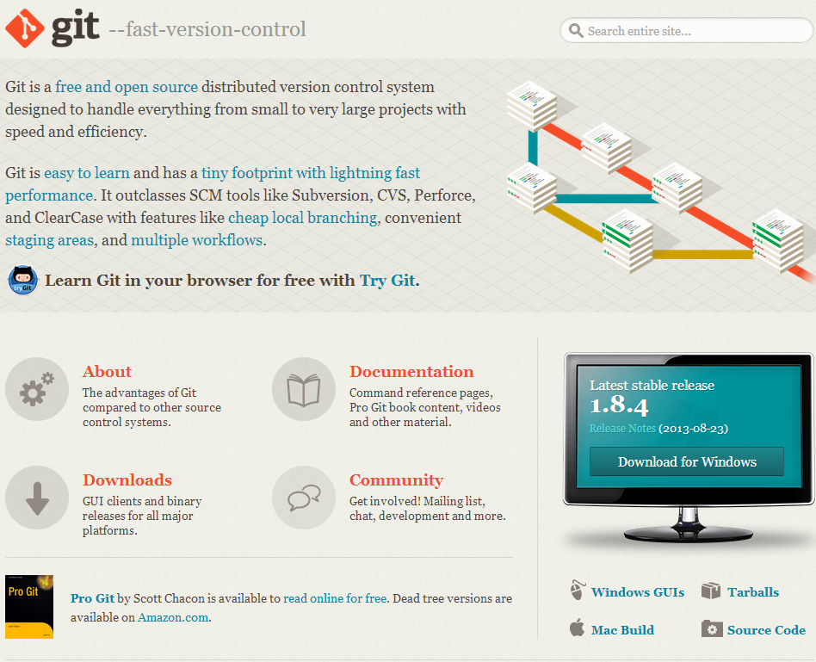

Run the downloaded EXE file and select the following components shown in the figure:

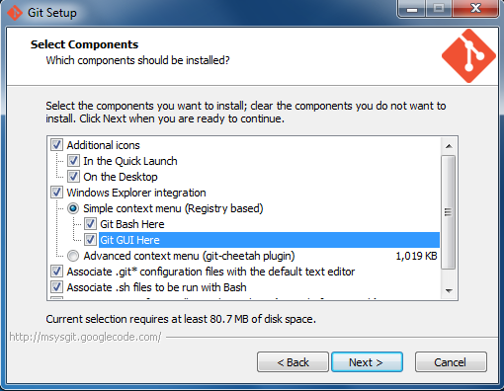

After finishing installation you will find the following icon on your desktop:

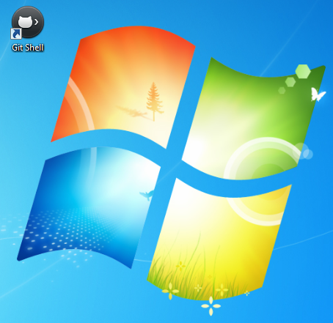

# Installation of SourceTree

SourceTree is a free Git & Mercurial GUI client for Windows or Mac. To download this software go to the website:

<http://www.sourcetreeapp.com/>

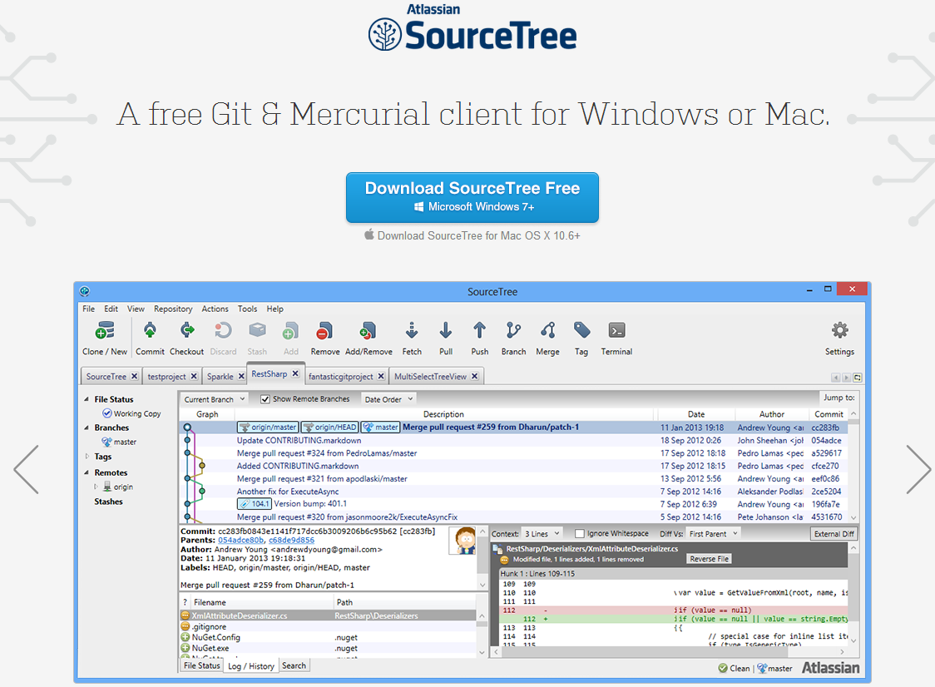

Click and Download the **SourceTreeSetup_1.2.3.exe** file and run it to install on your computer.

To open this software click on the shortcut as shown in the figure:

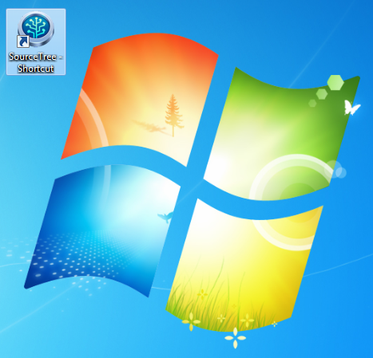

Now it will open the following windows.

